How to Join the
Animal Assisted Activity Team
& Assignment Guidelines

7.3.21
Table of Contents

Page
3 COVID-19 Update
5 Animal Assisted Therapy Program Mission
5 Animal Assisted Activity Benefits
How to Join the Animal Assisted Activity Team
6 Membership in a Qualifying Pet Therapy Organization
6 Application Request & Shadowing Visit
7 Veterinary Records & Dog License
7 Human Health & Security Clearances
8 Hospital Orientation and Animal Team Briefing
8 Mentored Visits
Assignment Guidelines Animal Assisted Activity Team
10 Handler and Escort Responsibilities
11 Dress Code, ID, Leashes
12 Scheduling
13 Pre-visit Preparation
13 Parking
13 Sign In/Out
14 Consent & Potential Visiting Candidates
15 Visiting Venues
15 Off-Limits Sections of Doylestown Hospital for Pet Therapy Teams
16 Contraindications for Contact with Animals
16 Handling Procedures
18 Canine Body Language
19 Guidelines for Appropriate Interactions (including HIPAA)
20 Infection Control
21 Animal Incidents
22 Animal Health & Zoonosis
22 Handler & Escort Health
23 Performance Input & Education
23 Communication & Outreach
Appendix
25 Animal Assisted Activity Veterinary Record Form
26 Preventative Heartworm Attestation Form
27 Commitment to Confidentiality Form

COVID-19 UPDATE

Thank you for your willingness to volunteer with your therapy dog in Doylestown Hospital. The comfort of an interaction with your therapy dog will be enjoyed and valued by Hospital staff and visitors, as well as patients.

To keep you, your therapy dog and the Doylestown Hospital community safe, we obviously need to require compliance with the current policies of your certifying agency, the CDC and Doylestown Hospital.

Take time to know your therapy agency policies via their website, a phone call, and/or member handbook, newsletters and emails.

CDC Recommendations from CDC.gov 6/30/21 related to therapy dogs follow.

Ways to protect therapy animals
Facilities that normally use therapy animals may not allow them at this time because people in many of these settings are at higher risk for serious illness with COVID-19. Follow local guidance and facility protocols for social distancing, face coverings, and other ways to prevent COVID-19 from spreading. If therapy animals are invited to a facility or other setting, follow the steps below.

Therapy animal visits require some level of contact between clients and the therapy animal team. When possible, keep animals at least 6 feet away from people and animals not participating in the visit. Handlers and participants should wear a cloth face covering during the visit.
Do not take therapy animals to visits if the animals are sick or have tested positive for the virus that causes COVID- 19.
People with symptoms of COVID-19 should not touch, be close to, or interact with therapy animals. If someone was sick with COVID-19, they should wait until they recover to interact with therapy animals.
Before and after every contact, the handler and anyone petting or having contact with the animal should wash their hands.
Do not use items that multiple people handle, particularly if items are brought to multiple facilities between therapy visits (for example, leashes, harnesses, toys, or blankets). If items like leashes must be brought between facilities, disinfect them after each use or facility.
Do not let other people handle items that go into the animal’s mouth, such as toys and treats.
Disinfect items such as toys, collars, leashes, harnesses, therapy vests and scarves, and food/water bowls frequently. Do not allow therapy animals to lick or give ‘kisses’.
Do not wipe or bathe therapy animals with chemical disinfectants, alcohol, hydrogen peroxide, or any other products not approved for animal use. There is no evidence that the virus can spread to people from the skin, fur, or hair of pets.
Do not put face coverings on therapy animals. Covering an animal’s face could harm the animal

If you are a service or therapy animal handler, and you get sick with COVID-19 or have symptoms of COVID-19, follow recommendations for what to do if you get sick and recommendations for protecting pets if you get sick.
If your service or therapy animal gets sick after contact with a person with COVID-19, call your veterinarian. If the animal tests positive for the virus that causes COVID-19, follow recommendations for what to do if your pet tests positive.

Doylestown Hospital COVID Policy for Therapy Dog Teams
1.Follow the current policies of the CDC and your therapy dog certifying agency, as well as Doylestown Hospital.

2.All Volunteers must wear a mask in patient care areas.
Masks are required in lobbies and waiting areas as well in-patient rooms.
Masks are not required in non-clinical areas in which patients are NOT present (offices, conference rooms, break rooms, etc.) regardless of known vaccination status.
Individuals should continue to wear masks if they are more comfortable doing so, and social distancing is always appropriate when feasible.

3.We recommend but do not currently require volunteers to be protected by a COVID-19 vaccination.
We request that handlers and escorts who have received a vaccination wear a button or mask that indicates that they have been vaccinated to help people feel confident about interactions with therapy dog teams.

4. As always, no visiting in any room with a contact precaution sign. If there is a COVID-19 patient in Doylestown Hospital, their room will have Novel Respiratory Precaution contact precaution signage as well as signage that requires gown, N95 mask, eye shield and gloves. No therapy team may enter a patient room with Novel contact precaution signage or any other contact precaution sign.

5. Until further notice, if you are making a therapy visit during business hours, begin your visit at the Volunteer Services Office. If you are visiting during the evening or on a weekend, contact the Volunteer Services office on the weekday afternoon prior to your visit.

6. The only areas of Doylestown Hospital that may be visited by therapy dogs until further notice are:
- Waiting areas, including Main Lobby and Same Day Service (SDS on 2nd floor) waiting areas
- Patient rooms on 2nd Floor North and 2nd Floor South, 3rd Floor West, 4th Floor East and 4th Floor West
- Business offices including Medical Records, Human Resources, Administration, and Accounting/Billing

7. No area in the Hospital other than those listed above may be visited by therapy dog teams. At this time, areas that therapy teams may not visit include Pediatrics, Cancer Institute, ICU, and the Cardiac Unit.

8. COVID Testing is available offsite at Drive-Thru testing center without a physician order.
For Vaccine-specific questions: COVIDvaccine@dh.org Use covid19@dh.org to submit COVID-related questions.

Artwork for this training guide courtesy of Anne Pizzini.

Animal Assisted Activity Program Mission

Lift the spirits of Doylestown Health patients, visitors, associates
and volunteers through interaction with qualified therapy dogs.
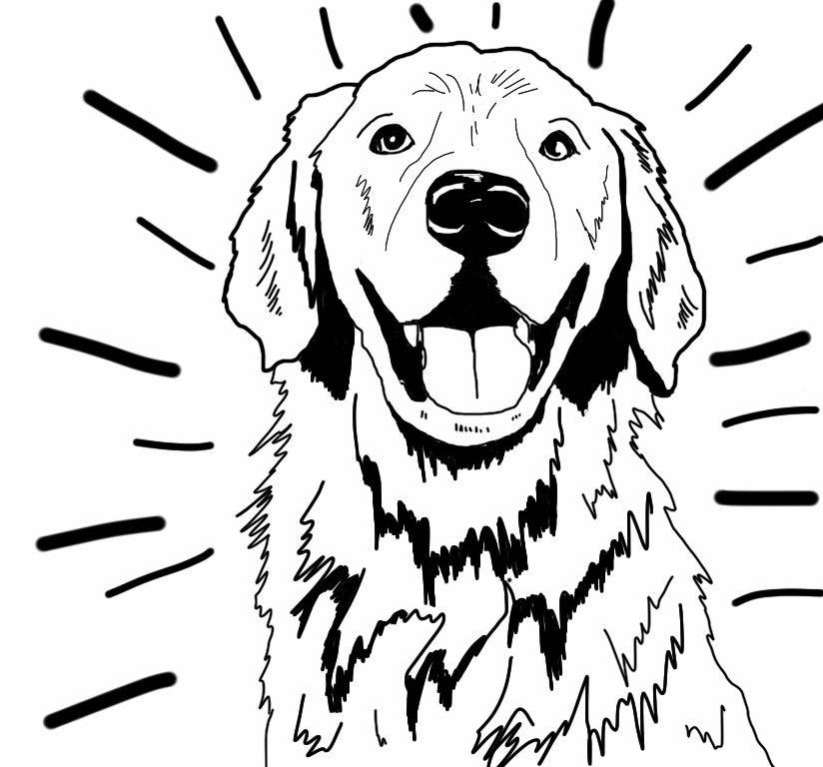

Dogs connect in ways humans cannot.

Animal Assisted Activity Benefits
A visit from a therapy dog is a real mood booster. A therapy dog handler has the pleasure of seeing people smile when they meet their therapy dog and hearing comments like this on every visit to Doylestown Hospital: “Your dog was the highlight of my day.”

Therapy dogs provide companionship and can reduce feelings of isolation and loneliness. Petting a dog leads to the release of oxytocin, a hormone and brain chemical secreted by the pituitary gland during social bonding.

Interacting with dogs is calming for humans and dogs alike. Petting a dog lowers stress-related increases in heart rate and lowers the blood pressure of both the human and the dog.

Interacting with a therapy dog can provide a distraction from pain and a respite from worry. Touching a therapy dog decreases the release of the stress hormone cortisol.

Most Americans are animal lovers who have or had a beloved pet. Seeing a therapy dog in a hospital unlocks pleasant memories of times with best friends in addition to the pure joy of spending time with an adorable, friendly, well-mannered therapy dog.

Sharing your therapy dog with a member of the Doylestown Hospital community not only makes a difference in how a person feels during your visit; a therapy dog interaction creates an upbeat topic of conversation and a pleasant memory.

How to Join the Doylestown Hospital
Animal Assisted Activity Team

1. Requirements
Dogs connect in ways humans cannot.

A. Membership in a Qualifying Pet Therapy Organization
- Doylestown Hospital’s therapy dogs and handlers are required to be registered therapy dog teams. Members of these independent pet therapy testing and registering organizations are welcome at Doylestown Hospital:
- Alliance of Therapy Dogs [formerly Therapy Dogs Inc.]: 877-843-7364; therapydogs.com
- Comfort Caring Canines: comfortcaringcanines.org
- Pet Partners [formerly Delta Society]: 425-679-5500; petpartners.org
- Therapy Dogs International: 973-252-9800; tdi-dog.org
Note that Roxy Therapy Dogs does not accept teams registered with Therapy Dogs International
Membership in another pet therapy organization will be considered provided testing, policies and insurance coverage is comparable to those of the organizations listed here.
- You are expected to contact the pet therapy organizations directly for information about requirements, testing process and venue, and to personally schedule your pet therapy testing.
- A copy of your current pet therapy registration card (with Alliance of Therapy Dogs, Comfort Caring Canines, Pet Partners, or Therapy Dogs International) must be included with your Doylestown Hospital Volunteer application.
- Doylestown Health requires all therapy dog teams to be active, unrestricted, insured members in good standing with their therapy organization and to be compliant with that therapy organization’s requirements.
- Membership in the Roxy Therapy Dogs organization (roxyreading.org) will be required to visit the Pediatrics Unit of Doylestown Hospital.
- Employees of Doylestown Health may not be volunteers due to the federal Fair Labor Standards Act.

B. Application Request & Shadowing Visit
- Once you have become a member of one of our qualifying pet therapy organizations, you should call the Volunteer Services Office of Doylestown Hospital (215) 345-2204 to request an application form.
- Prior to submitting your application, a registered pet therapy Handler must accompany an experienced Doylestown Hospital therapy dog team mentor on a shadowing visit. In addition to providing you with an opportunity to respond to questions about the application process and form, the shadowing visit lets you see the benefits of therapy dogs in a hospital setting and the necessary behaviors of a therapy dog before you invest the time and effort required to join the Animal Assisted Activity team.
- On the shadowing visit you will be asked to sign Commitment to Confidentiality form; a copy of that form is provided in the Appendix. We request that you wear sneakers or other comfortable shoes with a rubber-sole and conservative clothing on your shadowing visit. Your therapy dog does not attend the shadowing visit.
- Following the shadowing visit, prospective Animal Assisted Activity Volunteers must submit all required application materials and then interview with a member of the Doylestown Health Volunteer Office staff.

- The application includes the Doylestown Hospital Therapy Dog Behavior Checklist below which summarized performance expectations of therapy dog teams.

Yes | No | Doylestown Hospital Therapy Dog Behavior Checklist
 |  | Enjoys human interactions: Will your therapy dog enjoy interacting with hospital patients, visitors, and staff?
 |  | Calm and confident: Is your therapy dog unfazed by smells, sounds, and petting from people who may have motor-skills challenges?
 |  | Heels nicely: Will your therapy dog walk by your side on a loose leash (under control and without pulling) around potential distractions, including interesting people, food, unusual smells, and unexpected sounds?
 |  | Obedient: Will your therapy dog respond to your commands in a hospital setting, a challenging environment with fragile people and potential distractions including food, sounds, smells, moving equipment, and other therapy and service dogs?
Does not lunge or pull: Will your therapy dog be safe with fragile people and politely avoid those who don’t wish to interact?
Will your dog wait to approach people until you’ve given permission?
 |  | Responds to sit, stay & leave it commands: Will your therapy dog prioritize obedience over impulse and distractions?
 |  | Does not bark or vocalize in hospital: Can you count on your dog to be quiet (no barking or whining) in a hospital?
 |  | Won’t lick: Will your therapy dog be safe around topical medications, respect preferences of those who don’t want “kisses” and adhere to the CDC requirement that therapy dogs do not lick?

- A therapy dog may not enter the hospital until the entire application and orientation process has been completed. The shadowing visit and behavior checklist are opportunities for you to evaluate whether or not your therapy dog will be happy and safe in a hospital setting prior to applying to the program.

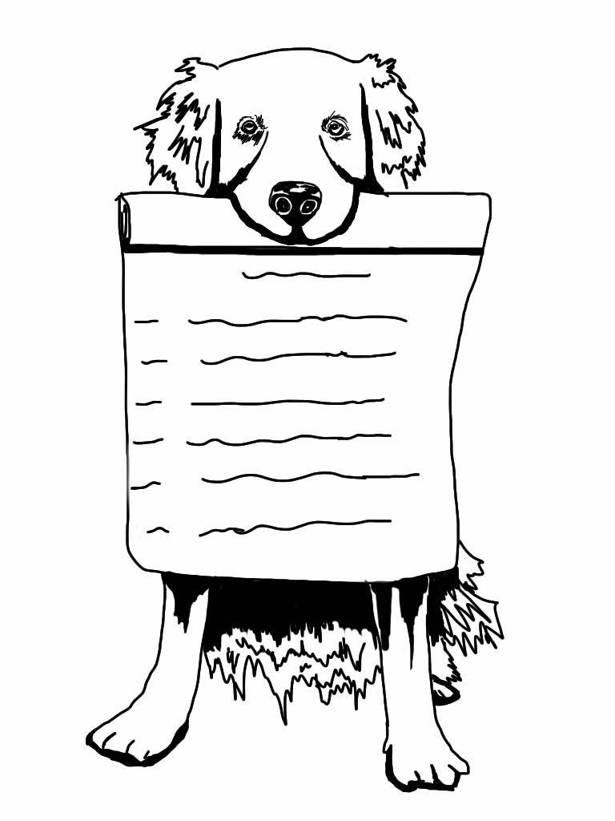
C. Veterinary Records & Dog License
- Animal Assisted Activity Handlers must provide documentation of the dog’s current health and inoculation records including the date of the most recent annual veterinary examination and administration and expiration dates of rabies vaccination, DHPP or DHLPP, and annual negative fecal exam. Either proof of current heartworm blood test with expiration date OR an attestation statement that monthly preventative heartworm medication is provided by the Handler must also be submitted with your application.
- Prior to their first visit, new Handlers are required to provide a Veterinary Record using the Doylestown Hospital Veterinary Record Form (provided in the Appendix along with the attestation statement).
- Any time your dog’s health or inoculation status changes, please submit an updated record to the Volunteer Services Office using the Doylestown Hospital Animal Assisted Activity Veterinary Record form.
- Animal Assisted Activity Handlers must provide proof of a current animal license as required by state law.

D. Human Health & Security Clearances
- All Volunteers must agree to abide by Doylestown Health policies and procedures and complete all required forms.
- All Animal Assisted Activity Volunteers must pass the PA State Police Criminal Background Clearance, FBI Fingerprint Clearance, and PA Child Abuse Clearance for Adults. Doylestown Health will complete the PA Criminal Record Clearance at no charge to the new Volunteer after the interview with the Director of Volunteer Services. At the time of application, Volunteers get direction on obtaining the FBI Fingerprint Clearance and PA Child Abuse Clearance. Clearances must be returned with the application. New Volunteers will be responsible for any charges associated with obtaining these two clearances initially; PA State Law requires these clearances to be repeated every five years. Doylestown Health will pay for repeat clearances for any AAA Volunteers who have completed 36 unsupervised visits.
- Animal program volunteers must be at least 16 years of age.
- Doylestown Health Volunteers are required to get two, two-step PPD (TB) tests before beginning to volunteer. Results of these TB tests must be read within 48-72 hours of testing. Doylestown Health provides PPD testing at no charge to the Volunteer.
- Every Doylestown Health Volunteer must receive an annual flu vaccine. Vaccines are provided at no charge by Doylestown Health. If Volunteers receive a vaccine outside the hospital, documentation of receiving the vaccine must be provided to the Volunteer Services Office.
- Animal Assisted Activity Volunteers must show proof of receiving a TDaP vaccine; that vaccine is given at Doylestown Hospital at no charge to the Volunteer.
- All Doylestown Health Volunteers are strongly encouraged to get a COVID-19 vaccination and provide documentation of their COVID-19 vaccination with their application. COVID-19 Vaccines are provided at no charge by Doylestown Health. It’s likely that Volunteers will be required to have COVID-19 vaccinations later this year when the FDA changes the designation of vaccines from “Emergency Use” to “FDA Approved.”

E. Hospital Orientation and Animal Team Briefing
- Following a successful application and interview, a new Animal Assisted Activity Volunteer must complete the Doylestown Health Orientation Process, which includes attendance at a hospital orientation session. Orientation is typically scheduled on a Monday morning, takes approximately five-hours, and covers hospital policies and procedures such as compliance with HIPAA, fire safety, sanitation, and other issues relevant to all new hospital employees and volunteers.
- An animal team briefing – Handlers without their dogs -- is required for all Animal Assisted Activity Handlers and Escorts prior to participation in supervised training visits. This one-hour briefing is a review of policies and procedures relevant to Animal Assisted Activity volunteers and an opportunity for Q&A.
- Therapy dogs do not attend either Hospital Orientation or the Animal team briefing.

F. Mentored Visits
- Therapy Dogs and their Handlers will be observed on a minimum of three mentored training visits before receiving approval to join the Animal Assisted Activity team.
- Mentored visits help Animal Assisted Activity Volunteers become acquainted with Doylestown Hospital and its Animal Assisted Activity procedures as well as help to identify the best volunteering opportunity within the hospital for the new Animal Assisted Activity team.
- Since the purpose of the therapy dog program is joy, another purpose of mentored visits is to make sure the therapy dog and handler enjoy spending time in Doylestown Hospital. Unfortunately, not every therapy dog is happy in a hospital setting. A registered therapy dog may or may not be comfortable with the smells, sounds, equipment, lighting, floor surfaces, and population in a hospital.
- Next steps following initial mentored visits may be approval to visit, additional mentored visits, or recommendations for training outside the hospital setting prior to additional mentored visits.
- If a therapy dog team needs obedience or other training to function safely and effectively in a Hospital setting, it is up to the therapy dog team to pursue that training outside the Hospital. Mentors may make suggestions on resources and training to consider.
- All therapy teams must visit with a mentor until training is complete.
- Upon completion of mentored training, Handlers will sign their Handler Training Checklist to acknowledge review and understanding of each aspect of training prior to visiting.
- Therapy dogs who participate in the Doylestown Hospital Animal Assisted Activity program must be calm, confident, controlled, and safe, and have the desire to interact with hospital patients, visitors, and staff.
- If a therapy team exhibits unsafe or uncontrolled behavior or barking, the mentor is required to end the visit immediately.
- Therapy dog teams receive written feedback from mentors and the opportunity to discuss their visiting experience and with the mentor who accompanied them on their visit.
- If a Handler has more than one registered therapy dog, each dog must be observed individually on mentored visits prior to becoming a member of the Animal Assisted Activity team.
- Escorts are required to successfully complete a minimum of one mentored visit.
- Therapy dogs receive their ID card and Doylestown Hospital bandanna after they complete the mentoring process.

We recognize that the steps required to join Doylestown Hospital’s Animal Assisted Activity team require significant commitment and an investment of time. We sincerely appreciate the dedication that our therapy dog teams devote to becoming a part of the Animal Assisted Activity program at Doylestown Hospital.

The training, visit preparation, skill, and care of our therapy dog teams ensure safe interactions with a diverse, and sometimes fragile population who rely on Doylestown Hospital to respond to their health challenges as well as the visitors, volunteers, and staff who protect and care for those who entrust their health to Doylestown Health.

The future of our therapy dog program requires careful documentation of the background information for and training completed by every therapy dog team by the organizations who evaluate and accredit hospitals, such as the Joint Commission, as well as professional, safe visiting practices by our therapy dog teams.

Our caring, conservative approach to documentation, policies, training and protects our people, our therapy dogs, and our Animal Assisted Activity program.

Animal Assisted Activity Assignment Guidelines

A. Handler and Escort Responsibilities
- An Animal Assisted Activity Team consists of one registered pet therapy team (one Handler and one therapy dog registered with that Handler). The Team must also include an Escort when Doylestown Hospital or the therapy team’s registration organization requires an Escort.
- Doylestown Hospital requires all Animal Assisted Activity handlers who are younger than age 18 to be accompanied by an adult escort at all times.
- Doylestown Hospital requires all Animal Assisted Activity teams to include an escort when visiting the Pediatric Unit. That escort may be a Pediatrics staff member.
- Handlers must follow the policy of their registration organization with regard to Escorts while visiting other areas of Doylestown Hospital.
- A Handler may choose to be accompanied by an Escort from the Doylestown Hospital’s Animal Assisted Activity team even if the Handler’s certification organization does not require an Escort.
- Doylestown Hospital requires Escorts on all pediatric visits and for junior handlers.
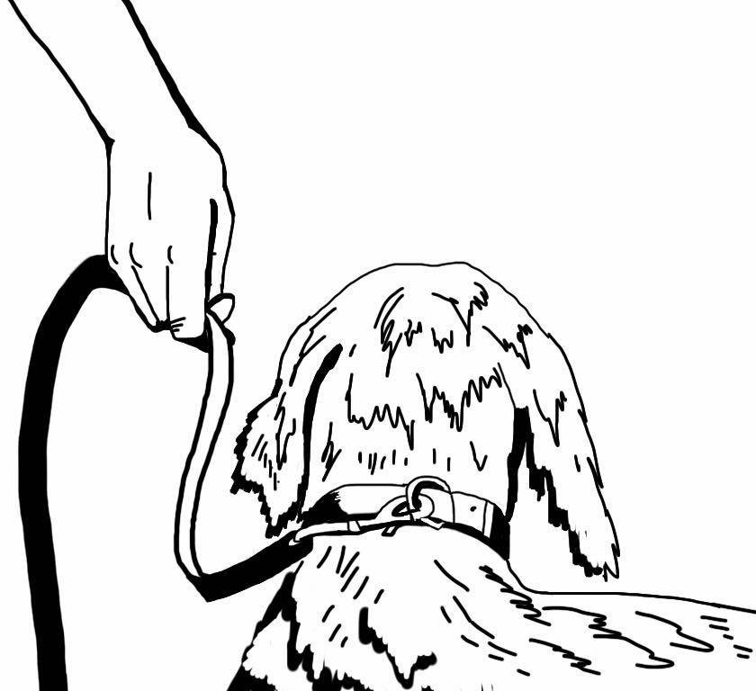
- No Animal Assisted Activity Handler may hold the leash of, or otherwise handle, any dog other than the Handler’s own registered therapy dog on the Doylestown Health campus.
- No Escort may hold the leash of or otherwise handle any registered therapy dog on the Doylestown Health Campus.
- A Doylestown Hospital Volunteer Handler may be an Escort for another team. While functioning as an Escort, a Volunteer Handler may not be accompanied by his/her own therapy dog.
- If the Pediatric patient census allows, a nurse or patient care technician may serve as an Escort for a therapy dog team visiting the Pediatric Unit. Note that at this time, Pediatric visits are not permitted.
- The following individuals may accompany a Handler and the Handler’s registered therapy dog on an Animal Assisted Activity visit:
Hold onto your dog’s leash at all times. When you let go of that leash, you let go of your pet therapy insurance.
- The Handler’s Escort
- Members of the Doylestown Health Animal Assisted Activity program for training, observation, and/or evaluation purposes
- Prospective members of the animal team with clearance for observation/training from the Volunteer Services Office and a signed Commitment to Confidentiality form (provided in the Appendix).
- Doylestown Hospital staff members cleared for observation of Animal Assisted Activity by the Volunteer Services Office

- Handler & Escort Responsibilities include the following:
Handler | Escort | Responsibilities
X |  | Manage behavior of therapy dog
X |  | Manage interaction with therapy dog
X |  | Hold therapy dog’s leash
 | X | Determine if a visit is appropriate
 | X | Obtain consent to visit
 | X | Introduce therapy dog
 | X | Provide/dispose of linen barriers
 | X | Move tray tables, chairs as appropriate
 | X | Provide hand sanitizer before and after every interaction
- Handlers take on the responsibilities of Escort as well as Handler if they make a visit without an Escort.

B. Dress Code, ID, Backpack, Leashes
- You must wear a mask in the Hospital in any area where is or might be present, including lobbies and waiting areas as well as in-patient rooms.
- We request that you wear a button that indicates you’ve been vaccinated if you have followed the Hospital’s recommendation to get a COVID-19 vaccination.
- Animal Assisted Activity volunteers must wear a Doylestown Health shirt or jacket with long khaki pants and sneakers or other flat, rubber-soled shoes.
- Roxy Therapy Dogs requires Animal Assisted Activity Volunteers in the Pediatric Unit to wear a shirt with the Roxy and Doylestown Health logos (which is available through the Volunteer Services office of Doylestown Hospital).
- Escorts and Handlers should refrain from the use of cologne, perfume, and scented products to respect patients who may be sensitive to scents.
- Doylestown Health photo-IDs must be worn by Handlers and Escorts.
- ID badges are created and provided as part of the orientation process for human volunteers.
- Therapy dogs get an ID badge when the handler and therapy dog have completed the mentoring process.
- Animal team volunteers should display the human and therapy dog volunteer IDs on the lanyard provided by Doylestown Hospital.
Prominently display your and your dog’s Doylestown Health ID cards for the benefit of patients, visitors, and staff, including security professionals. Your pet therapy organization also requires you to have your certification card with you when you visit.
- Handlers must have a copy of their current therapy organization card in their possession at all times when their therapy dog is in the hospital. We suggest that you place that card in the pocket of your lanyard.
- Teams must conform to the credential display requirements of their pet therapy organization.
Your therapy dog should wear the tag or other special identifier required by your therapy organization.
- We request that your therapy dog wear their Doylestown Hospital scarf.
- Roxy therapy dogs should wear their Roxy scarf (instead of the Doylestown Hospital scarf) while visiting in the Pediatrics unit. Note that Pediatric visits are not permitted at this time.
- To make it clear that you are a member of the Doylestown Hospital Animal Assisted Activity team, we ask that you wear the Dog’s Heal backpack and use that backpack to store your visiting gear.
- Gear that we suggest storing in your backpack includes: extra mask, hand sanitizer, therapy dog’s leash and collar with therapy tag, ID badges for you and your dog, Doylestown Hospital bandanna, Roxy bandanna, water bowl/water, poop bags, clean up gear (paper towels, wipes), comb for your dog, lint roller, and personal items (keys, wallet, pen, cell phone which is turned off).
- Dogs must be leashed at all times and the Handler – not the Escort --must always hold the dog’s leash regardless of where the team happens to be on the grounds of the campus, including rest rooms.
- Teams must use the leash and collar/harness approved by their certification agency for their dog.
- Prong collars, pinch collars, chain, and choke collars which may trap and injure patients’ fingers are not acceptable at Doylestown Health. Doylestown Health advocates the use of a flat buckle collar.
- Therapy dogs should not wear any flea/tick collar during visits.
- Leashes must be non-retractable and no longer than six (6) feet.
- Dogs must be on an appropriate leash or harness or in a pet carrier at all times while anywhere on the grounds of the Doylestown Health campus.
- At this time, you may not let a visitor or staff member brush your dog or “help” adjust a dog’s bandanna or other gear.
- Clean your gear after every visit.

C. Scheduling
- Teams are requested to make one visit per week and required to make a minimum of one visit per month, on average, over the course of twelve months.
- Handlers sign up for a specific visiting schedule through the Volunteer Services Office. Visiting schedule specifies day(s), week(s), and time; for example, “first and third Tuesdays between 2pm and 4pm.”
- Handlers sign up for a 90-minute window with the understanding that they will visit with their dog for about an hour within that 90-minute frame. The 90-minute window is meant to provide flexibility for the Handler and respect for extra time that may be needed with a dog prior to entering the hospital.
- Handers are expected to stick to their schedule.
- Contact the Volunteer Office 215-345-2204 or klangley@dh.org if you wish to change your established visiting schedule or location on an ongoing basis.
- One-time changes in scheduling are not feasible.
- Handlers should email klangley@dh.org -- do not call -- if you cannot make a scheduled visit.
- If a Handler cancels a visit, their next visit is their next regularly scheduled date and time.
- Teams are scheduled and approved to visit multiple specific locations within the hospital with the understanding that it may not be practical to visit all locations on a single visit given variations in patient population and time spent on interactions.
- Teams must stick to their scheduled time and approved visiting locations for contact tracing and because, for the safety of all, multiple therapy dogs must not be in the same area at the same time.
- Handlers consult the Escort List when they have a need for an Escort, and then Handlers contact Escorts directly via phone or email to identify an Escort(s) who is available during the Handler’s visiting schedule.
- Handlers schedule visit(s) with their Escorts.
- Handlers and Escorts decide if an ongoing partnership as a team is desired after their initial visit(s) together.
- Handlers advise the Volunteer Office when they have established a visiting partnership with an Escort.
- Escorts follow the schedule of their assigned Handler, making sure they arrive in time to escort the Handler and dog into the hospital. Teams who require an Escort may not enter the hospital without an Escort.
- When their usual Escort is not available, it is the responsibility of the Handler to find another Escort or to email klangley@dh.org and cancel the visit if the Handler’s therapy organization requires an escort. The regular Escort may agree to find a substitute for the Handler.
- Handlers and Escorts must communicate with each other directly about precise arrival times and scheduling changes.
- Handlers and Escorts should contact each other and be sure the message is received if there’s a need to cancel a visit.
D. Pre-Visit Preparation
- Make sure your dog has adequate rest, nutrition, and hydration.
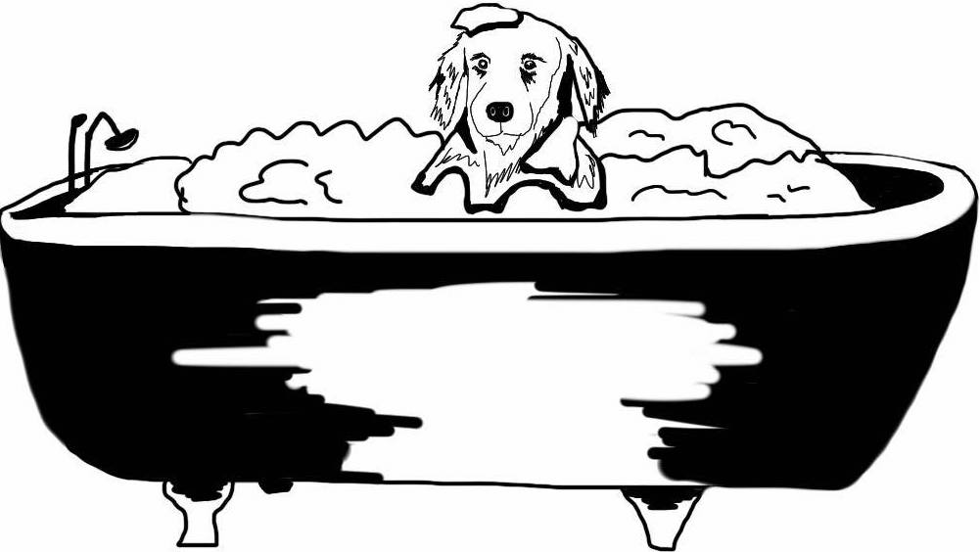
- Your dog’s coat should be brushed or combed before a visit to remove debris and as much loose hair and dander as possible.
- Your therapy dog’s nails should be short and free of sharp edges.
- Be sure the dog is clean and smells good when visiting. As necessary, bathe the dog with a mild, ideally, unscented hypoallergenic shampoo and allow the dog’s coat to dry.
- Brush the dog’s teeth as appropriate.
- Inspect the dog for fleas and ticks.
- Visiting animals must be healthy, parasite free, and on a flea control program.
Take time to make sure your dog looks and smells good before each and every visit.

- Pets may not be treated with a topical medication such as Frontline within 48-hours of a visit.
- Maintain animal leashes, harnesses, and collars so they are functional as well as visibly clean and odor-free.
- It’s helpful to maintain a visiting bag that includes your mask and a back-up mask, your ID, your dog’s ID, visiting collar and leash, therapy vest or scarf, poop bags, paper towels or wipes, lint roller, hand sanitizer, water and a collapsible water bowl.
- Transport your groomed therapy dog to the hospital in a clean carrier.
- Provide your dog with an opportunity to eliminate immediately before entering Doylestown Hospital.
  - Handlers may use the grass areas around the Hospital’s parking lots to potty their dog.
  - Use an outdoor trash can to dispose of waste and practice hand hygiene immediately afterward.
- Make sure your dog is ready to visit before you enter the hospital. Pay careful attention and be responsive to your dog’s body language when you put the “therapy clothing” on your dog.
- Allow enough time for you and your dog to settle before leaving the sign-in area and beginning your visit. Pursue appropriate calming, exercising, or energizing procedures necessary to prepare for a visit. Only visit when and if your dog is ready to visit.

Parking
- Animal Assisted Activity volunteers may park in Parking Lot C or in lots E, G, or H. There are grass areas near the lots where you may potty your dog.
- Volunteers have the option to park on the first two floors or the parking garage for a fee of $2 per day. If you can walk and potty your dog before you come to the Hospital, the parking garage is a way to stay dry during inclement weather since the garage connects to the main Hospital building.

E. Sign-In/Sign Out
- A registered therapy animal may be on the grounds of Doylestown Hospital only if they are with their registered Handler acting as an Animal Assisted Activity Volunteer.
- Handlers may only bring one registered therapy dog who has completed the Doylestown Hospital training process to Doylestown Hospital on a visit even if they have more than one dog who is a member of the Hospital’s Animal Assisted Activity program.
- Escorts and Handlers registered with a therapy organization that requires Escorts at all times must:
  - Meet outside the Main Entrance of the Hospital.
  - Enter the hospital together through the main lobby.
  - Sign-in with your volunteer numbers on Doylestown Health electronic system at the computer station near the entrance of the hospital.
  - Sign-out at the computer station near the main entrance.
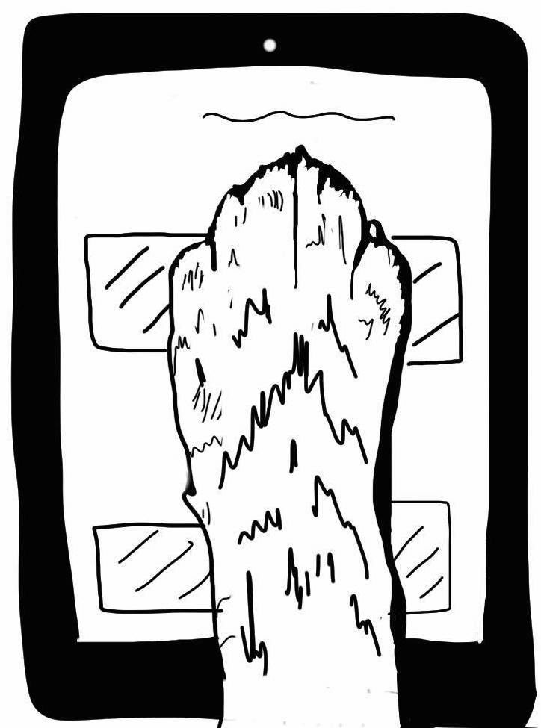
- The sign-in computer screen provides personalized reminders (due dates for dog’s inoculations and licenses and handler’s security clearances and therapy organization renewals) as well as room numbers of patients who requested a pet therapy team visit.
- If a team is interested in earning AKC therapy dog titles, the Volunteer Services Office can write a letter (based on your computerized sign-in records) that you may submit to the AKC to document your visiting history.
- If a Handler arrives before the Escort, the Handler and dog should wait outside (outdoors) until the Escort arrives.

F. Consent & Potential Visiting Candidates
- Verbal consent is required prior to interacting with all adult hospital patients, visitors, volunteers, and staff anywhere on the campus.
Sign in and sign out on a touch screen kiosk.
- A signed permission slip must be in place before visiting a patient in the Pediatric Unit. Pediatric Unit staff will ask parents/guardians to sign the permission slip as part of the admission process. The Handler or Escort should check with the Pediatric Unit staff to determine which pediatric patients can have a therapy dog visit. Note that no visits to the Pediatric Unit are permitted at this time.
- Before any therapy dog interacts with a child who is on the hospital grounds, but not a patient in the pediatric unit, verbal consent is required from the adult accompanying the child along with a verbal or body language OK from the child.
- Determine whether or not a patient is a candidate for Animal Assisted Activity prior to seeking consent from a patient. Animal Assisted Activity is not permitted with patients with any contraindication for contact with animals. Rooms marked to indicate contact precautions may not be entered by any member of the animal Team. If there is a COVID-19 patient in the Hospital, their room is off-limits to therapy dog teams and will be identified with Novel contact precaution signage.
The charge nurse can be consulted to identify other patients who may not participate in animal assisted activity, including those with an allergy or fear of animals, patients with aggressive behavior, open wounds, neutropenia, HIV infection, immunoglobulin deficiencies, isolation restrictions, or an illness that can be transmitted to animals. Patients with a tracheotomy may be seen only if the tracheotomy is covered with oxygen or capped.
- The escort should give each patient who is a candidate for a visit the option to agree or decline a visit before the Handler and therapy dog enters the patient’s room. A Handler who is not required to have an Escort should ask for the patient’s consent at the maximum distance possible from a patient, ideally from the doorway. Keep in mind that some people choose not to interact with an animal because it is one of the few decisions they may make in a hospital setting. Respect the wishes of each person graciously.
- Postpone visits with patients who are in consultation with medical professionals, eating, on the telephone, or involved in an activity that is best left uninterrupted.
- Visitors in patient rooms should, when possible, be given the option to interact with the therapy dog.
- Before entering an elevator with an animal, ask the passengers for permission. Do not enter an elevator if any passenger expresses reluctance or appears apprehensive. Dogs should be either carried or placed in a “sit” or “down” while in the elevator and should exit the elevators slowly, being mindful of the need not to startle or approach without asking permission when the elevator door opens.

G. Visiting Venues
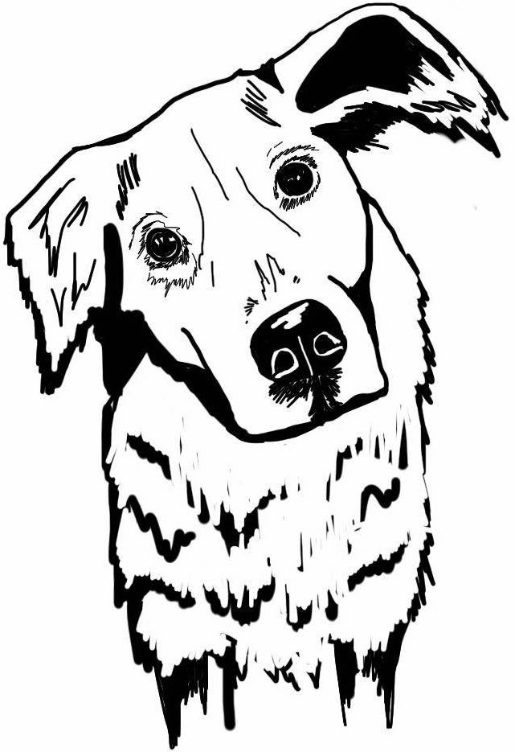
- Animal Assisted Activity Handlers are expected to visit with their dog in their scheduled visiting destination(s).
- Teams are encouraged to go directly to patient areas first and then to visit with staff, volunteers, and visitors in public areas following patient visits.
- Avoid all restricted areas and do not agree to any visit requested in a restricted area.
- The only areas of Doylestown Hospital that may be visited by therapy dog teams until further notice are:
- Patient rooms on 2nd Floor North and 2nd Floor South, 3rd Floor West,
- 4th Floor East, 4th Floor West, including 4th floor West Orthopedic Institute
- The following waiting areas:
  - Main lobby entrance area
  - Lab testing waiting area on 1st floor, near info desk/coffee bar
  - Same Day Service waiting areas on 2nd floor above main lobby
  - Maternity waiting room on the 2nd floor
  - Orthopedic Institute waiting room on 4th floor west
- Business offices including Medical Records (1st floor near Volunteer Office), Human Resources, Pastoral Care, Administrative (near 2nd floor waiting area above Main Lobby), Accounting/Billing (ground floor), and Volunteer Services.
Be mindful of what patients AND your dog are saying and feeling.

H. Off Limits Sections of the Hospital
- Therapy dog teams may not visit any Contact Precaution rooms in any area of the hospital
- Therapy Dog Teams may not visit any area not specifically mentioned in this document as an area where animal teams may visit.
- At this time, therapy dog teams may not visit any of the following areas:
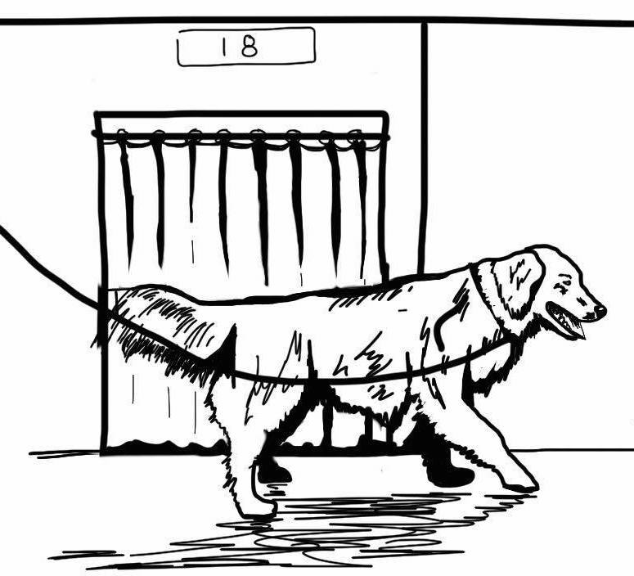
- Pediatrics
- Cancer Institute
- ICU
- Cardiac Unit
- Moss Rehab
- Operating rooms, recovery rooms, cardiac catheterization suites, and endoscopy suites
- Imaging areas 1st floor: MRI Center, CT Scan, Interventional Radiology, Ultrasound & Nuclear Medicine
- Silverman Community Health Clinic (ground floor)
- Rehab areas 1st floor: Cardiac, Pulmonary, Hand, Occupational Therapy, Physical Therapy, Speech Therapy
- Maternity, including in-patient rooms, neonatal, and new-born nurseries
Please don’t promise a visit. Not all patients can interact with therapy dogs due to contact precautions. Sometimes patients are not available because they are sleeping or due to testing, medical consultations, or treatments.
- Emergency Room and ER waiting area
- Wound care and Wound Care waiting area on first floor
- All patient lavatories
- Food preparation areas
- Pharmacy (medication storage/preparation areas)
- Clean linen storage rooms
- Clean/sterile supply storage areas
- Any area in the Pavilion Building, including Penn Radiation Oncology, infusion therapy areas, physician practice areas, and testing areas

I. Contraindications for Contact with Animals: applies to all Hospital areas and all teams
- Teams may not visit any patient room labeled for contact precautions: Droplet, Airborne, Contact or Enhanced Contact, or Strict Isolation Precautions.
- Avoid contact with any patient whom a staff member says not to visit. The charge nurse can be consulted to identify patients who may not participate in animal assisted activity, including those with allergy, fear of animals, aggressive behavior, open wounds, neutropenia, HIV infection, immunoglobulin deficiencies, isolation restrictions, illnesses that can be transmitted to animals. Patients with a tracheotomy may be seen only if the tracheotomy is covered with oxygen or capped.
- Staff members, visitors, volunteers, and patients must be asked whether or not they would like to meet a dog and only those who say yes are appropriate for interaction.
- Respect the decision of all who choose not to interact because they are allergic, fearful, busy, or simply not in the mood.
- Postpone visits with patients who are in consultation with medical professionals, eating, on the telephone, or involved in activity that is best left uninterrupted.
- If there is an unusual or unpleasant smell in a patient room or any other condition with the potential to disturb your therapy dog, avoid that room. Notify a staff member if you have a concern about a smell or other issue.
- If there is any doubt in your mind about whether or not to visit an area or a patient, do NOT make the visit.

J. Handling Procedures
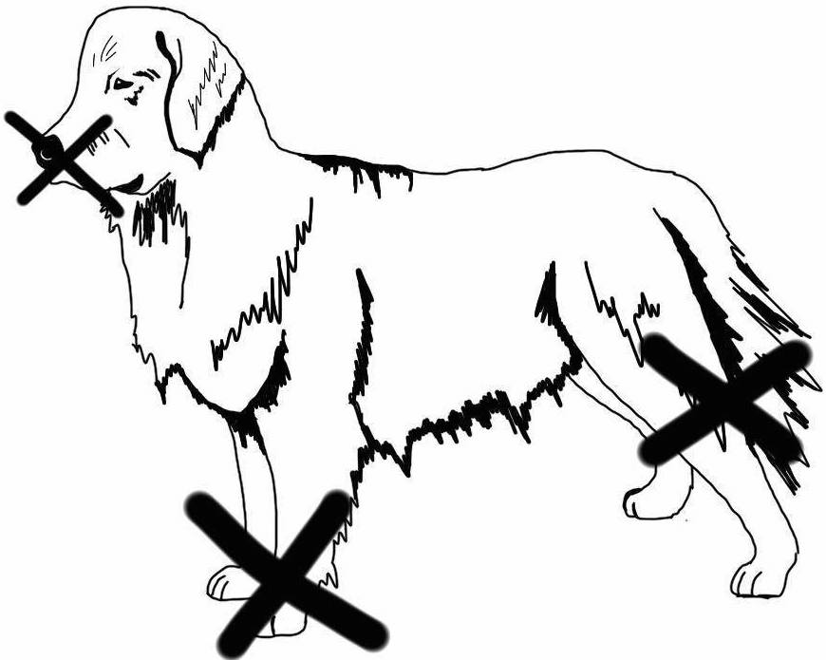
- Therapy dog teams must follow all policies of the CDC and their pet therapy organization. Compliance is required for your pet therapy insurance to be in force.
- Handlers, Escorts, and participants in the therapy visit must wear a mask.
- It is the responsibility of the Handler to maintain control of their therapy dog at all times while on the premises of Doylestown Health.
  - It is the responsibility of the registered, insured Handler, not the Escort or staff, to manage the behavior of the animal.
  - It is not appropriate for anyone other than the Handler to hold the therapy dog’s leash.
  - Only the Handler may pick up an animal. If it is appropriate for a small dog to be placed on a patient’s lap or next to a patient, the Handler should very carefully place the dog with the patient (using an appropriate linen barrier) while keeping the dog on leash and remaining next to the patient.
Letting someone know where your dog likes to be touched is a kind way to direct people away from your dog’s mouth, feet, and back end.
  - Before any large dog places its head on a patient's bed to make it easier for a patient to pet, a linen barrier should be used.
  - Therapy dogs should not be on furniture in the hospital.
- Handlers must supervise every animal interaction and prioritize the well-being, safety, and comfort of their animal. Handlers are expected to monitor their dog throughout their visits and to be alert for indications of stress, fatigue, thirst, hunger, overheating, or the need/urge to eliminate. If using appropriate calming techniques (including, but not limited to, changing the dog’s position, taking the dog away from the potential source of stress, or taking the dog outside) does not remedy a dog’s discomfort, the day’s visit should end immediately, without regard for planned length of the visit.
- Handlers should take action to prevent (or, if necessary, immediately stop) activity that might increase the likelihood of frightening, harming, or arousing the dog, or causing accidental harm to the person interacting with the dog, the Handler, the Escort, or the therapy dog.
- Use particular care to prevent allowing a therapy dog to be touched on inappropriate body sites (e.g., mouth, nose, feet, perianal region).
- Prevent your therapy dog from contact with any invasive medical devices such as intravenous lines (IVs) and catheters.
- The way you position your dog can keep your dog safe by preventing an unsteady hand from touching your dog’s face or rear. The position of your dog can also prevent your dog from licking. Placing your dog in a sit or stand next to the person they are visiting or facing out rather than eye-to-eye with a person protects your dog’s eyes and keeps your dog’s mouth away from temptation. Placing a small dog (under 15 pounds) in a bed or chair facing out rather than eye to eye is safe practice. It’s nice to say something like, “Sparky likes his back scratched” when you put your dog into position.
- Animal Assisted Activity volunteers should avoid interaction between animals while on the grounds of any Doylestown Health campus.
Service dogs are sometimes in the Hospital and there are occasions when a patient has an Rx that allows a visit from a pet dog. Ideally, you should avoid or leave the area if you see another animal. Do not make contact with another animal. If your only option is to pass by, command your dog’s complete attention and heel carefully; do not pause to interact. Pick up your small dog if that’s practical.
- Therapy dogs must be leashed and the leash held by the Handler at all times unless the animal is in a carrier.
- The therapy dog’s leash should be loose rather than taut. A tight leash is an indication that a dog is pulling and not under the control of the Handler.
- The therapy dog should be next to its Handler. A leash can be a safety hazard when a dog is out of position.
- While in hallways, heel your dog close to a wall to provide space for others to pass by.
- Take time to carefully observe the patient and to notice the medical equipment and devices in the room.
- Approach patients from the side that is free of any invasive devices (such as intravenous catheters) and prevent the animal from having contact with any catheter insertion sites, medical devices, breaks in the skin, bandage materials, or other compromised body site.
- If the Handler and therapy dog are not accompanied by an Escort, the Handler will perform the duties of the Escort:
  - Determine whether or not each patient is a candidate for Animal Assisted Activity.
  - Make sure the timing is appropriate for a visit.
  - Give each person the option to meet or not meet the therapy dog before the dog enters a patient room or approaches a visitor or staff member.
  - Provide and dispose of linen barriers as appropriate.
  - Move (and replace) tray tables and chairs to facilitate interactions.
  - Provide hand sanitizer to anyone who wants to interact with a therapy dog both before they touch your therapy dog and after they touch the dog. Facilitate use of hand sanitizer if necessary.
  - In the event of an animal bite or scratch, immediately inform nursing staff who will provide or facilitate appropriate clinical care. A witnessing staff member should file a Problem Event Form.
  - Report any animal incident to the Volunteer Office as well as the registration organization. Incidents include, but are not limited to, bites, scratches, excessive barking, and destructive behavior.
- Encourage your therapy dog while you visit. Let your dog know he/she’s doing a good job.
- Give your dog as many breaks as necessary.
- Use of treats is discouraged; animals should focus on people and be motivated/rewarded by human interaction.
- Volunteers should not respond to any medical questions and should not provide food or water to any patient. Instead, tell the person who asks a medical question or requests food or water that you will ask a nearby staff member to respond to the question/request and then let a nearby staff member know about the question/request.
- If you see a medical situation that you think may require immediate attention, notify a nearby staff member.
- Avoid cell phone use and participating in other activities that divert attention from animal interactions.
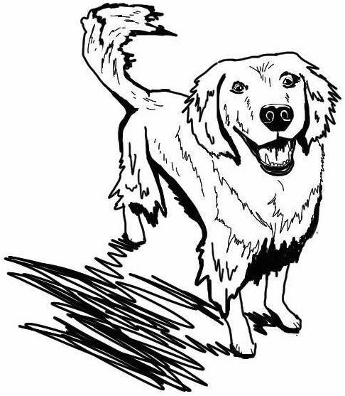
- If the dog is facing a different direction than its Handler, the dog is typically communicating “let’s go” and the Handler should respond to the dog’s need to leave.
- After visiting, give your dog positive reinforcement, personal attention, adequate nutrition, bathing/cleaning as appropriate, and rest.

K. Canine Body Language
- Handlers should monitor their dog for body language cues prior to, during, and immediately after the visit. Respect what your dog is telling you and respond to body language cues.
Avoidance behaviors – when a dog is anxious and/or wishes to stop or get away from what’s happening – can include excessive sniffing, inattention, turning head, turning body, moving away, hiding behind a person or object, barking, retreating, and submissive rolling.
- Displacement behaviors are indications of stress exhibited when a dog feels internal conflict, or is uncomfortable, or afraid. Displacement body language can be typically normal, yet out of context behavior, such as yawning, lip/nose licking, scratching/biting at paws, biting at other objects, or a wet dog shake.
This dog’s body language shows that he is happy and ready to visit.
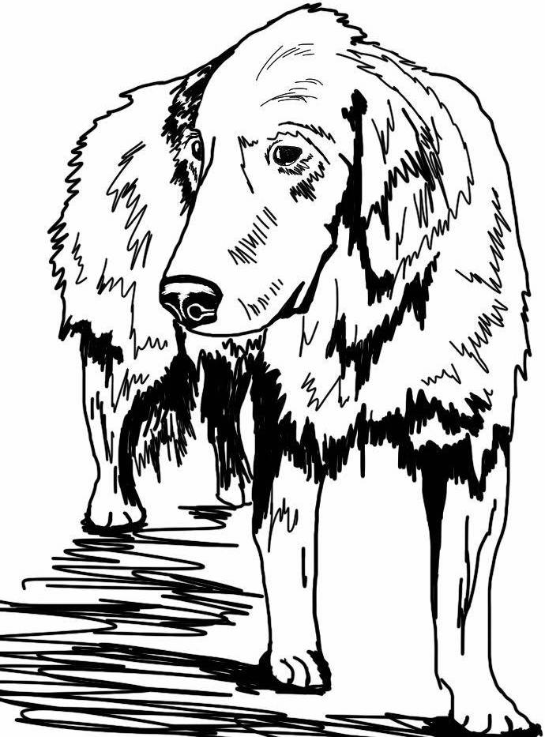
- Other signs of dog anxiety can include tucked tail, excessive panting, restlessness/pacing, dilated pupils, tense muscles around eyes/mouth, low body posture/shifting weight to back end, excessive shedding, excessive whining/vocalization, ears pinned back, and “whale eye” (displaying whites of the eye).
- Arousal behaviors (precursors to barking, pulling, jumping up, aggression, and other behaviors inappropriate in a hospital) can include play bow, staring, slow tail wag, muscle tenseness, hackles raised, body leaning forward, high-pitched growling and barking.
- Evaluate your dog based on an examination of your dog’s entire body and the situation.
- If you see your dog exhibiting displacement, avoidance, anxiety, arousal, or other warning behaviors, leave the area/situation immediately. Take your dog to a quiet area and soothe him/her. Give the animal a break outdoors and/or end the visit immediately based on your dog’s needs and behavior.
- Pet Partners offers an excellent online canine body language course. You need not be a Pet Partners member to take that course.
https://petpartners.org/learn/online-education/canine-body-language-course/

This dog’s body language indicates real stress and the need to end the visit. Take a break and soothe your dog when you first see a signal that your dog may be uncomfortable with a situation. Be your dog’s advocate and prioritize safety.

L. Guidelines for Appropriate Interactions
- Customize every Animal Assisted Activity interaction experience based on human needs and preferences as well as the characteristics of the therapy dog. A patient who does not want to pet an animal may want to look at the therapy dog and talk about the animal.
- Introduce your dog by name.
- Encourage dialog about pets and animals. Asking if the patient ever had a pet often leads patients to pleasant memories. Talk about your dog in a way that prompts questions and engages interest. Describing your dog’s breed or rescue, age, weight, diet, tricks, and favorite activities can stimulate conversation.
- Do not introduce yourself. Keep the focus on your dog.
- It is a conflict of interest and inappropriate to mention a current or past profession or employer. When you are in the hospital with your dog, you are representing Doylestown Health’s animal team.
- Regardless of your background or profession, when you are in the hospital as an Animal Assisted Activity volunteer, under no circumstances should you offer any medically-related observations, advice, or recommendations.
- In the event that you encounter a medical emergency, or suspect a medical emergency:
  - Dial 2222 immediately and keep your dog under your control while you make the call.
  - Leave the area with your dog and report the emergency to the first clinical associate you encounter.
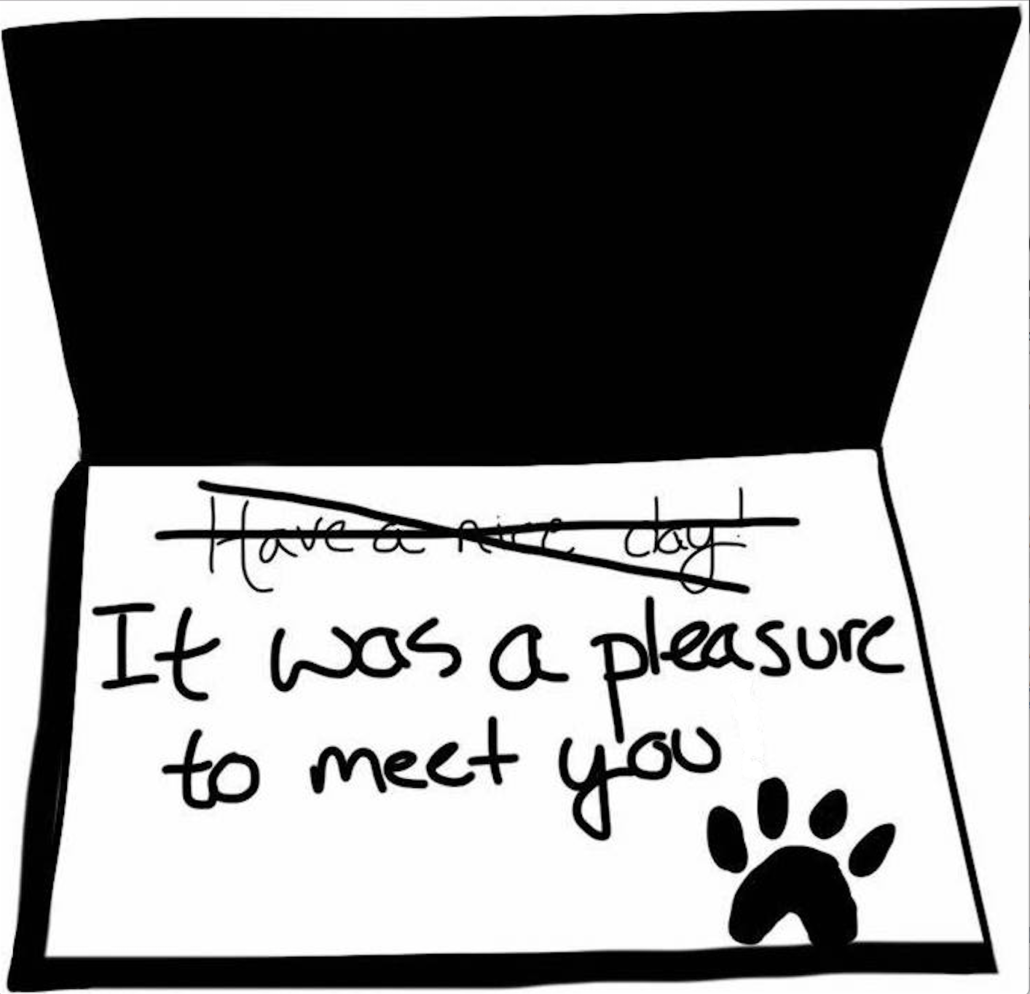
- Always be sensitive to the individual’s medical and emotional situation; for example, conclude visits with a remark like “It was a pleasure to meet you” rather than comments that are not sensitive to a person in a hospital. “Have a nice day” or “Hope you feel better” are not appropriate when speaking to a person with a serious injury or illness. Never refer to a person that you are visiting as a patient; treat and refer to each person as an individual.
- Be alert for cues that signal the desire to end the visit. “Thank you” is often a polite dismissal. A break in eye contact can also signal desire to end an interaction.
- Give anyone who wants to touch your therapy dog hand sanitizer before they touch your dog. Ask any person who touched your dog to use hand sanitizer to again at the end of the visit.
Most patients and visitors in a hospital would probably rather not be there. People are in pain and missing loved ones. Choose your words with kindness.
- Make your offers of hand sanitizer in a kind and friendly way.
You can say, these days everyone uses hand sanitizer both before and after they touch a therapy dog.
This is one of the ways we keep everyone safe and follow CDC guidelines.
“How about a squirt of hand wash?”
If a person has difficulty applying hand sanitizer, you may assist or ask a clinical person to do that.
Wash you own hands frequently.
- Therapy dog interactions need not involve touching the therapy dog. Seeing a therapy dog and talking about pets brings pleasure. Watching a therapy dog do a simple trick like “spin” is fun.
- Respect HIPPA/confidentiality policy.
  - Remember to protect privacy by strict adherence to confidentiality.
  - Never ask anyone their name.
  - Introduce your dog but not yourself.
  - Do not ask any questions about anyone’s medical condition or personal situation.
  - The only medically-related question that is appropriate to ask is whether or not it is appropriate to interact with a therapy dog.
- Do not use your phone or camera to take photos of you or your therapy dog with patients, visitors, volunteers, or staff.
- Others may take a photograph of your therapy dog with your consent.
- If requested, you may take a photograph of your therapy dog with a patient, visitor, volunteer, or staff using the requesting person’s camera or phone (but not with your phone or camera).
- All clinical questions from patients, families, or visitors should be referred to clinical associates.
- In the event that you discover a fire, dial 5555. Practice fire safety policy as per RACE acronym:
Rescue – Remove and/or assist in the removal of those patients who may be in immediate danger. Patients should be moved away from the fire beyond fire and smoke doors.
Alarm – Every fire must be reported, regardless of the type or extent. Volunteers should know where each fire alarm pull station is located in their assigned areas and how to operate them.
Dial 5555 for the hospital operator, tell him/her WHERE the fire is located, WHAT is the type and extent and WHO is calling.
Contain – Reduce the spread of fire and smoke by closing all doors and windows, turning off all fans and air conditioners.
Evacuate & Extinguish – by using the closest proper fire extinguisher on the fire as directed. In case of a fire, remember: An alarm will signal the location of a fire. The elevators will not be in use.
Never shout FIRE!
- All volunteers are expected to reflect the SERVICE values of Doylestown Health:
We serve the community
We strive for excellence in our services and programs
We respect the dignity and privacy of all
We provide value through high quality, accessible services
We seek innovation and integration for continuous improvement
We are compassionate
We are committed to the health and wellness education of our community

M. Infection Control
- Always carry hand sanitizer. Bottles of hand sanitizer are available at the Volunteer Services office.
- Handlers should require used of hand hygiene both before anyone touches their animal and after a person has touched your therapy dog.
- Handlers must prevent animals from coming into contact with sites of invasive devices, open or bandaged wounds, surgical incisions, or other breaches in the skin, or medical equipment.
- If the patient or agent requests that a small dog be placed on the bedside or lap, the Handler should check for visible soiling of bed linens first. Do not place a small dog on the bed or lap if soiling is present.
- Provide a barrier of fresh hospital linen for each patient when it is appropriate for a small dog to be on a patient’s lap or bedside, or for a large dog who places his head on a bed for easy access for the patient.
- Fresh linen should be used for each patient. A pillowcase, sheet, or towel may only be used for one patient.
- Place hospital linen that has been used in dirty linen bins, or give linen to nurse, volunteer, or staff member to place in a bin.
- If a dog has contact with surface of the bed, staff should be advised that the linen should be removed and laundered.
- Use a lint roller if you notice that your therapy dog had shed.
- Handlers may not sit or perch on a patient’s bed, but may sit on a chair. Sitting is a positive; when you sit you are signaling your desire to spend time with a patient.
- Prevent the dog from licking patients, visitors, and staff. Topical medication can be dangerous for dogs and licking or “kisses” are unwanted by some people. CDC does not permit licking.
- Discourage patients, visitors, and staff from “shaking hands” with therapy dogs who obviously recently walked outdoors and on hospital floors.
- For the protection of the patient and your dog, do not allow patients or visitors to feed your therapy dog. Your dog’s reward is the interaction.

N. Animal Incidents
- In the event that an animal becomes ill on a visit and produces any bodily discharge, assist with preliminary clean up, contact housekeeping by calling 2020, then terminate the visit immediately and withdraw the animal from visitation for a minimum of one week or as advised by a veterinarian.
- In the case of an animal “accident,” immediately terminate the visit.
  - Take appropriate measures to prevent recurrence during future visits (observation of elimination immediately prior to visiting, exercise, appropriate timing of food and water).
  - Submissive urination requires suspending the animal’s visiting privileges, having the Handler address the underlying cause, and then formally reevaluating the animal’s suitability before visiting privileges are restored.
  - If repeated “accidents” occur, the animal’s visiting privileges will be withdrawn.
- Routine cleaning and disinfection of environmental surfaces is done by the environmental services department of Doylestown Hospital.
- In the event of an animal bite or scratch or any suspected physical injury, immediately inform nursing staff who will provide or facilitate appropriate clinical care. A Problem Event Form will be filled out by a witnessing staff member.
- A visit should be immediately terminated after any incident.
- Report any animal incident to Volunteer Services as well as the registration organization immediately. Incidents include, but are not limited to, illness/bodily discharge, bites, scratches, excessive barking/vocalization, destructive behavior, and animal “accident.”
- Public health or animal control authorities should be informed as required by local laws.
- The team’s therapy registration organization and Volunteer Services should be contacted immediately if there is any act of aggression by a therapy dog in any venue at any time.
- Doylestown Hospital has the option to suspend or terminate following the investigation of an incident.
- Bites, intentional scratches, or other serious, inappropriate behavior is cause for permanent withdrawal of the animal’s visiting privileges.
- In the case of other incidents, contributing circumstances will be considered and appropriate measures, including additional training, may be pursued to prevent similar issues from reoccurring. If measures cannot be taken to reduce the risk of recurrence, then visitation privileges will be withdrawn.
- Handlers must suspend visits and have the therapy dog formally reevaluated whenever the Handler notices or is apprised of any of the following in the therapy dog:
  - A negative behavioral change since the time it was last temperament tested
  - Aggressive behavior outside the healthcare setting
  - Fearful behavior during visits
  - Loss of sight or hearing resulting in an overt inclination to startle and react in an adverse manner
- The Volunteer Services Office of Doylestown Hospital requires clearance from the animal’s therapy organization and veterinarian before the team resumes therapy visits following an incident or issue.
- Inform the Director of Volunteer Services and Animal Assisted Activity Advisory chair of any inappropriate patient, staff, visitor, or volunteer behavior, including inappropriate dog handling and refusal to follow instructions.

O. Animal Health & Zoonosis
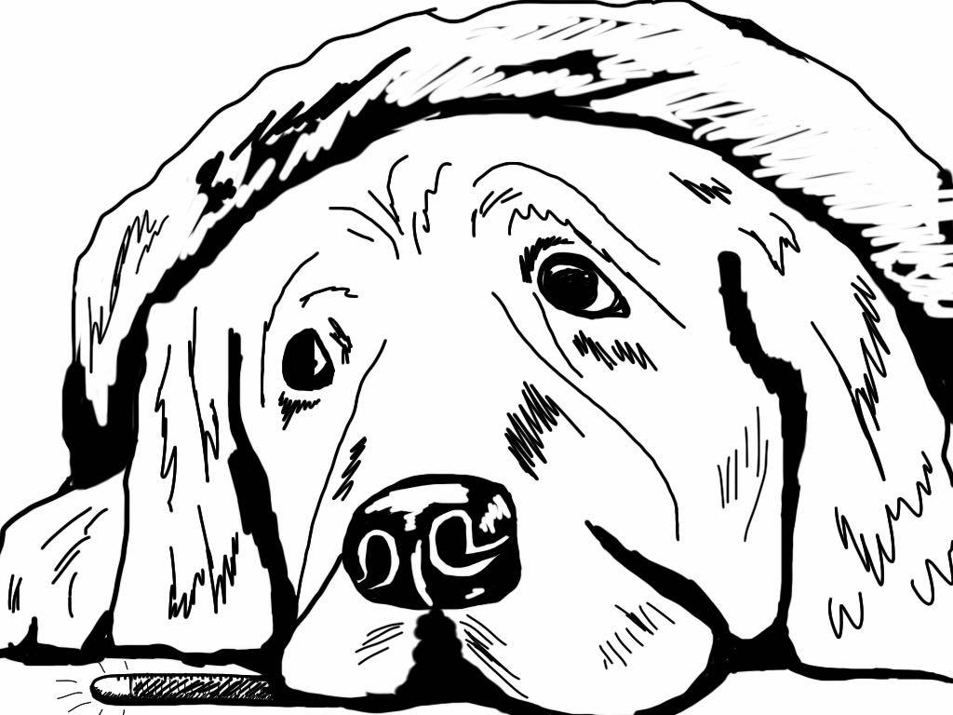
- Patient, visitor, volunteer, or staff member should use hand sanitizer before and after touching a therapy dog.
- Consider the use of dog cleansing wipes after patient interactions.
- Bathe your dog before and after visiting.
- Clean your gear after visits.
- Dogs are required to receive a health evaluation by a licensed veterinarian at least once per year and to submit an Animal Assisted Activity Veterinary Record Form signed by their vet at that annual visit to Volunteer Services. A copy of that Vet form is provided in the Appendix.
- Be compliant with your veterinarian’s recommendations regarding an appropriate flea, tick, and enteric parasite control.
- Cancel a visit if your therapy dog seems unwell or injured.
Be conservative. If you or your dog doesn’t feel well, cancel your visit.
- Animals with suspected communicable diseases may not visit.
- Animals with any contagious or concerning medical conditions should not visit until clinically normal, or the condition is managed and written veterinary health clearance is provided.
- Zoonosis – diseases that may be communicated from dogs to human – are very uncommon and can be prevented by vigilant Handlers.
  - Bite or scratch wound: prevented by careful handling by registered, trained therapy dogs
  - Rabies: transmitted via bites/open wounds; prevented with required rabies inoculation
  - Ringworm: transmitted via contact with skin lesions on a dog; prevented by eliminating visits by any dog suspected of having or diagnosed with ringworm
  - Gastrointestinal infection: transmitted when a dog’s fecal matter is ingested orally by a human; hand sanitation is essential and preventative; dogs with or suspected of having GI infections should not visit
  - Leptospirosis: transmitted via human ingestion of urine or discharge of affected dog; prevented by inoculation and careful handling of registered, trained therapy dogs; no visits by any dog suspected of having or diagnosed with leptospirosis
- Animals should not visit while demonstrating signs of heat (estrus).
- Animals who have been fed, within the past 90 days, any raw or dehydrated (but otherwise raw) foods, chews, or treats of animal origin, excluding those that are high-pressure pasteurized, irradiated, or fermented, may not visit patient areas.

P. Handler & Escort Health
- All volunteers are strongly encouraged to be vaccinated for COVID-19.
- Animal Assisted Activity Handlers and Escorts are encouraged to have all immunizations recommended for healthcare providers within Doylestown Hospital, including measles, mumps, and rubella (German Measles) and varicella (chicken pox) or have immunity to these diseases through having had the disease. Volunteers who have questions about their immunization status should speak to their personal physician to determine the need for vaccinations and/or boosters.
- All pet therapy volunteers are required to have a flu vaccine every year. Doylestown Hospital provides that vaccine at no charge.
- Proof of TDaP or obtaining the TDaP vaccine must be done before beginning to volunteer.
- The flu vaccine and TDaP vaccine are available at no charge through Doylestown Hospital’s Occupational Services. High dose flu vaccines are NOT available through the Occupational Health department.
- Handlers and Escorts must be free of contagious disease and avoid visiting if exposed to contagious disease.
- Handlers and Escorts should self-screen for symptoms of communicable disease and refrain from providing animal-assisted activities services while ill. Such symptoms include, but are not limited to:
  - New or worsening respiratory symptoms (i.e., cough, sneezing, nasal discharge)
  - Fever (temperature >100°F)
  - Diarrhea or vomiting
  - Conjunctivitis
  - Rash, poison ivy, non-intact skin on face or hands
- Avoid patient rooms with contact precaution signs to protect you and your dog.
- Handlers and Escorts should avoid direct contact with patients.
- Handlers and Escorts should personally use hand sanitizer before and after patient visits.
- Handlers and Escorts should provide emergency contact information to Volunteer Services.

Q. Performance Input & Education
- All Hospital Volunteers (and staff) are evaluated on an annual basis.
- After the first year of service, Animal Assisted Activity Handlers and Escorts will be evaluated using the Animal Assisted Activity Therapy Dog Team Competency form.
- The registered Handler with his/her own registered animal will be evaluated using the Team Evaluation form at least every three years; ideally, an independent evaluator will do that evaluation.
- When therapy dog-Handler team returns to Doylestown Hospital after an absence of more than four months, their first visit must be an accompanied visit to update the Handler on happenings with the Animal Assisted Activity program at Doylestown Hospital as well as to confirm the performance of the therapy team.
- Members of the Animal Assisted Activity team are strongly encouraged to attend team meetings which are held approximately twice per year. Team meetings are a forum for feedback, program updates, and educational seminars.

R. Communications & Outreach
- Handlers and Escorts must communicate openly with each other. Identify potential problems or issues during and following visits. Offer constructive input. Let your partner know he/she is appreciated.
- Be a proactive communicator. Share insights, exceptional interactions with patients, problems, potential issues, and suggestions with Karen Langley, Director of Volunteers klangley@dh.org 215-343-2204 and Joyce Rivas, Advisory Chair of the Doylestown Health Animal Assisted Activity Team, joycerivas@comcast.net
215-588-9201.
- Identify potential volunteers. Put people interested in volunteering on the Animal Assisted Activity Team in touch with Volunteer Services (215) 345-2204 and encourage them to go to doylestownhealth.org/and visit the Get Involved section of the website or Google “Doylestown Hospital therapy dog.”

Hazardous Materials: None.
Essential Functions: Animal handling, walking, standing, seeing, kneeling, stooping, reaching, and talking.
How to Join the Animal Assisted Activity Team &Assignment Guidelines updates:
9/14; 10/14, 12/14; 01/15; 03/15; 08/15; 09/15; 3/16; 7/16, 5/17, 2/20, 6/21, 7/21

Appendix
Animal Assisted Activity
Veterinary Record

We appreciate your assistance in completing this form for our Handlers so that they may participate in the Animal Assisted Activity Program at Doylestown Health. All of our Handlers are Volunteers who give their time and talent to our patients, families, visitors and staff without expectation of monetary compensation.

Owner’s Name________________________________________________________________________

Address______________________________________________________________________________

______________________________________________________________________________________

Phone ____________________________________

This certificate is to certify that I have carefully examined the following dog on:

Dog’s Name_______________________________________________ Date _______________________

Sex: M F Breed_______________________________________________

Immunization
Rabies Date Given______________ | Expiration Date ________________
DHPP/DHLPP Date Given______________  Or Titer | Expiration Date ________________
Fecal Positive □ Negative □ | Next time Due__________________
*Heartworm Test Positive □ Negative □ | Next time Due__________________
*If the Handler treats their dog with monthly preventative heartworm medication rather than getting a yearly heartworm blood test, the Handler must complete the attached Attestation.

I have examined this animal and, in my opinion, this animal is a good candidate to be a therapy dog at Doylestown Hospital. I have not seen any aggressive or inappropriate behavior in my presence. The animal appears to be healthy and free of pain, disabilities and illnesses that can cause unusual behavior that could cause the animal to be unpredictable. To the best of my knowledge, this animal has not been exposed to and is free of any infectious or contagious disease.

Remarks: __________________________________________________________________________

____________________________________________________________________________________

Name of Veterinarian _____________________________________________________

Signature of Licensed Veterinarian ___________________________________________

Address ____________________________________________________________________________

Date ______________________________________

Animal Assisted Activity
Heartworm Preventative

ATTESTATION

I hereby attest that I, _____________________________________________________,

administer preventative heartworm medication to my therapy dog, ____________________________, monthly.

I declare that this statement is true and accurate to the best of my knowledge.

________________________________________________________________________
Signature

____________________
Date

Commitment To Confidentiality

I, ____________________________, understand my obligation to maintain complete confidentiality of information in order to protect Patients and their families, as well as all members of the Doylestown Hospital family, from improper disclosure of information given in confidence, particularly when the information is related to the health, business, or personal matters of Patient, Patient’s families, Associates, Volunteers, or Members of the Board or Medical Staff. I also understand that confidentiality must be maintained regardless of the source of information, for example:
- Spoken word
- The medical record (patient’s chart)
- Computer records
- Records of Doylestown Hospital business such as financial
reports, statistical data, minutes of meetings, personnel files, etc.
and that access to information and dissemination of information are both subject to confidentiality standards.

Signature: __________________________________________

Date: _______________

5/2017; 5/2018; 5/2019; 5/2020; 06/2021
55/2017

